**Case Study**

The instances of supermarkets store are growing in the large populated areas, which increases the competitiveness in the market. The following data set reflects a historical sales information about asupermarket company with records of the sales effected on three different branches for three months. Such kind of techniques of predictive data analytics can be effectively applied to this dataset.

**Designing a Comprehensive Decision Support System (DSS)**

# Understanding the retail store dataset

Understanding the Retail Score Dataset

The dataset considered herein includes historical sales taken from the operations of a supermarket chain with records of transactions conducted at three branches for the whole of 2022. This large set of data provides a large panorama of the sales activity, the customers’ conduct and the evolution of branches during one year.

Key attributes in the dataset include:Key attributes in the dataset include:

* Invoice ID: A code that the program uses for sales record identification used in evaluation of individual sales.
* Branch: Specifies the branch at which the sale was made, with three branches indicated as A, B, and C Branch branches is something that can be used to compare the performance in the different branches.
* City: It identifies the branch in which each of the above outlets is located: geographical factors give greater clarity on locationoriented sales.
* Customer Type:Discriminates between those who have a membership card and are termed as ‘Members’ and those who don’t and are termed as ‘Normal’. This classification is useful for evaluating customer repeat patronage and buying behaviours.
* Gender: Grants storage of the gender of customers, which gives a demographic view of the purchasing tendencies.
* Product Line: Subcategories products into gadgets and apparels and clothing, Foods & juices & beverages, Health and cosmetics General home products, Sports gadgets and travelling. This attribute is useful in measurement of sales and comparing the sales performance of various products offered.
* Unit Price: Defines the price at which each product is sold in USD, including the crucial aspect of total sales, and assessing prices to make necessary adjustments.

Through such attributes, the dataset can provide detailed analysis about the performance of the branches and the segment of the customers for the entire year as well as the sales trend. It is with these that there is a good basis in building a Decision Support System (DSS) in support of improving strategic decisions and operations.

# Designing a Decision Support System (DSS) Using Power BI

Power Bi is selected for this project as it is simple yet powerful tool for business intelligence and its very flexible with multiple data types and data models, external tools such as ALM ToolKit, Tabular Editor are integrated in it making it more diverse and optimal tool for designing decision support systems.

## Components

## Database integration

The capability of the Decision Support System (DSS) that involves in the storage of data is the database. In this project, the only table of the database is the ‘retail_sales’ table which has been created by importing an Excel file of the corresponding name. Some of the attribute in this dataset are Invoice ID, Branch, City, Customer Type, Gender, Product Line, and Unit Price. To conduct effective analysis and for achieving highest levels of data efficiency in the output of Power BI, the data is cleaned and formatted within the same.

## User Interface:

The conceptual interface of the DSS reflects the quality of the end-products and since a user only wants to see results, the system allows any stakeholder access the data and make conclusions. The interface is created in Power BI with the help of the tools which are a part of it. Some of the functional components of the UI are as follows: Interactive dashboards, slicers and filters, and drilled down. These elements let the users interactively navigate through the data, look at information in the detail and filter their view according to branching, customer type or the type of product. The UI is designed in a way that complex data is effectively communicated and converted into realistic decision making tools.

Analytical Tools:

Analytical tools used in the DSS are consistent to offer details solutions and to support decisions thereon. In Power BI, this entails a number of visualization features that are bar charts, pie charts, line graphs as well as heat maps. These are used for various analyses of the sales data some of which include branch analysis, customers analysis as well as product analysis. There is use of DAX (Data Analysis Expressions) used to build more measures and calculations deepening the capability of the tool. Another method that can be integrated in the assessment of sales is the use of predictive analysis as well as trending which is used in making some forecast of the future sales as well as identify the trends in the market.

## Reporting Capabilities

The features of the DSS are designed to support detailed and summary reports insofar as users’ analysis is concerned. The reporting feature in Power BI is used to design and develop detailed reports and dashboards in order attract and influence the target audience easily. Some of the ways of presenting it can be in form of graphs, charts, tables or even a written text which gives the summary of the findings together with some important indicators commonly referred to as KPIs. In terms of report generation and analysis, users have options for format and can export in PDF or Excel format amongst others, generate reports automatically at fixed intervals to ensure timely delivery of reports.

## Data Integration and Transformation

Data load in Power BI contains bringing data in a suitable format from the Excel file to the Power BI environment. It involves data cleaning, data loading or transformation and data modeling. Data quality maintenance deals with data gaps, while data transformation prepares the data in a way suitable for the analysis. There is a possibility of defining relations between different attribute and between tables by using data model that will make querying to be accurate and efficient. There are two processes involved in data manipulation in Power BI and these are performed using Power BI’s Query Editor.

Detailed Analysis of The Data

# Total Sales By branch

Measurement of the Gross Income Fluctuations by Branch for 2022

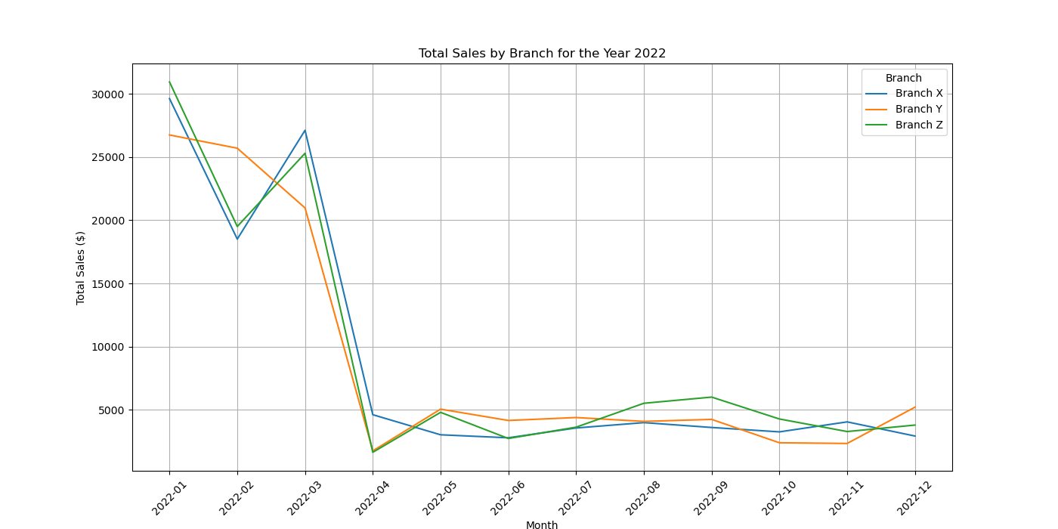

The gross income line for 2022 displays this by a negative trend across the board and most especially the 2nd quarter. As for Branch X, it suffered from lower income in these months, but this number was only partially replenished in July and again declined throughout the rest of the year. The same trend was observed for Branch Y, although there was a clear increase in activity in August, and fluctuations in activity in May and December. Similarly to branch Y, branch Z’s variability was very large, it had significant decrease in April, June and October, but also increased its performance in August and September.It raises the possibility of other market factors or seasonal trends affecting all the branches of the business. To eradicate these declines the branches should work on the specific causes and adapt their plans in the best way possible so as to improve the income and the performance of the branches for the entire year.

# Top Selling Products

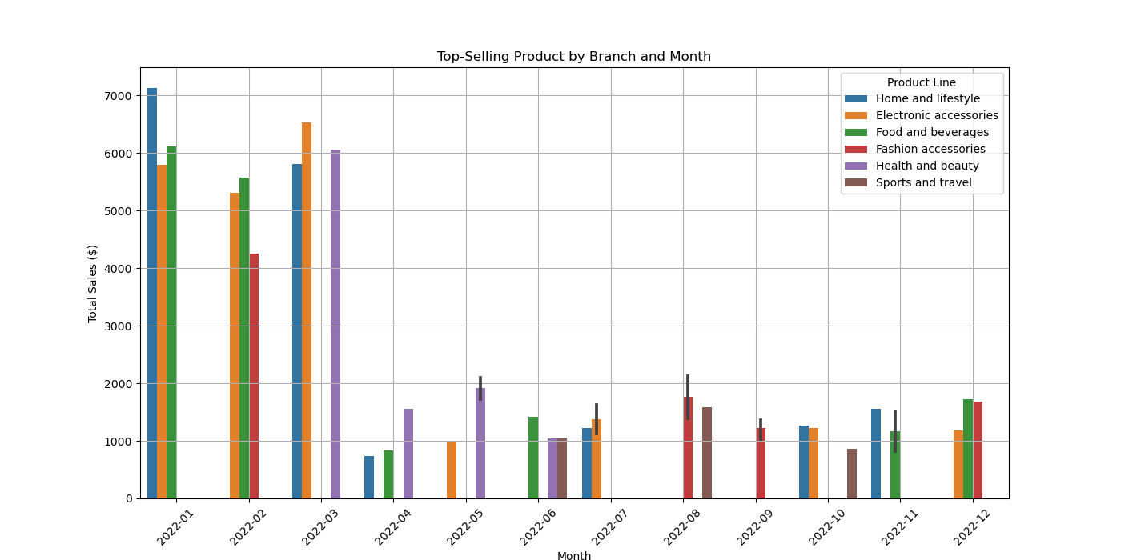

From the Branch X analysis, ‘Home and lifestyle’ category was the most popular and highly selling throughout the month with the highest sales figure of $7135 registered in the first month of the year. This has an implication that customers prefer these products in their initial purchasing cycle in the year. Other product lines like; “Health and beauty” and “Electronic accessories” also introduced fluctuation with incrementation in specific months like May and December.

In Branch Y ‘Electronic accessories’ was the highest selling product line in some of the months such as January and July. This shows that these products were much appreciated by customers in this branch of the company especially in mid of the year. While ‘Cosmetics’ dominated, there was variation in consumers’ choice of products for the other months, which includes ‘Fashion accessories’ and ‘Sports and travel’.

Sales at Branch Z were wider and more diverse and they were all within a period of 3 months. ‘Food and beverages’ was most popular by far, with the highest sales recorded in January and December. This means that these products enjoy wide patronage from the customers in Branch Z in every part of the year. The branch also recorded good sales in ‘Fashion accessories’ and ‘Electronic accessories’ at some times of the year such as August and October.

Branch Z realized the highest total sales for the year at $30246.23 and was followed by Branch X at $29746.). 37, Branch X at $30698, Branch Y at $28597. 04. Such a status proves that Branch Z was the leader in terms of the highest grossing performance of total sales.

Among the product types, “Electronic accessories” and “Food and beverages” sold the most, with amounts of $23781. 99 and $17991. 77, respectively. This speaks volumes of the market niche for these categories in all branches of the business.

For Each Branch there is a hero product.

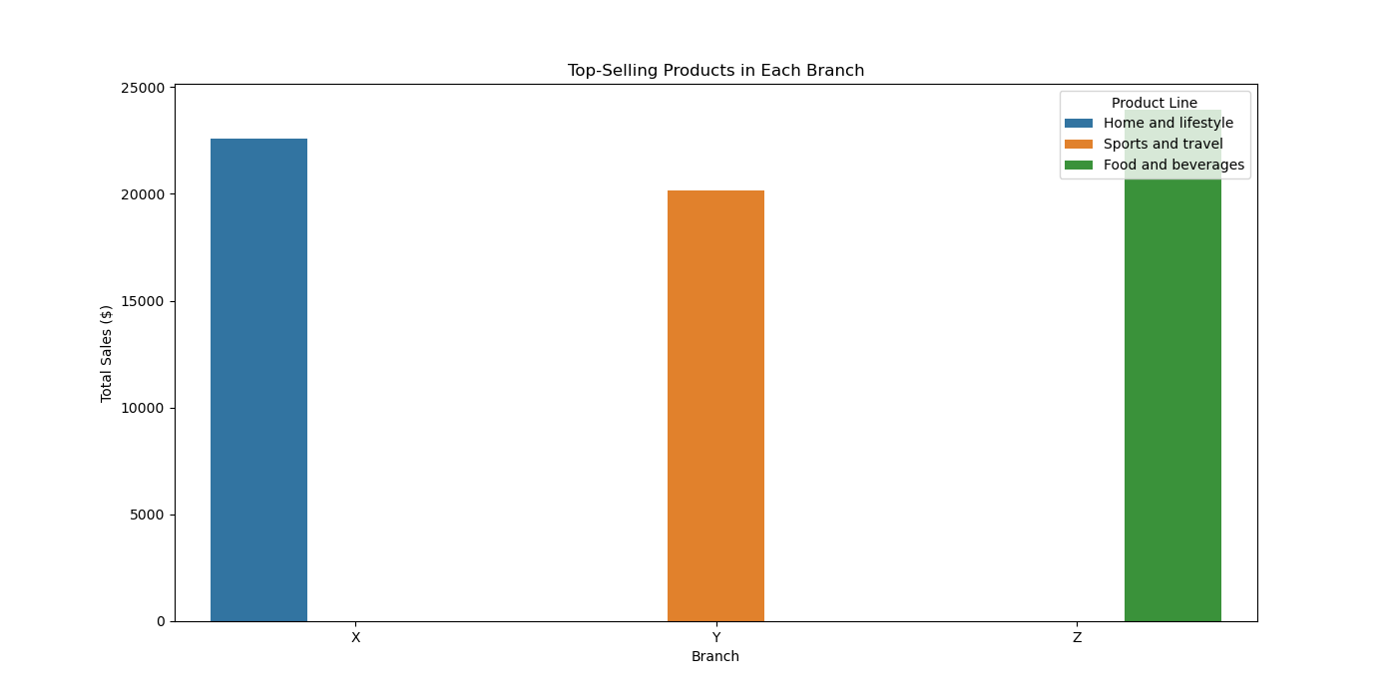

|  |  |
| --- | --- |
| Branch | Hero Product |
| X | Home and lifestyle |
| Y | Electronic accessories |
| Z | Food and beverages |

# Monthly Sales Comparison

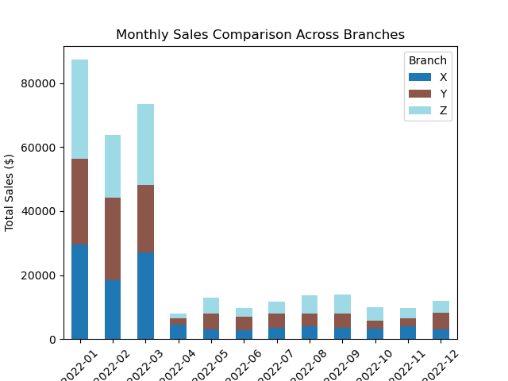

Using the data on monthly sales in the year 2022 it is evident that there are difference performance patterns of the three branches. Branch Z remained and outperformed the other branches in several ways and especially in terms of branch sales for most of the year especially in August and September. This may point to a strong market signalling and possibly, effective promotional or operating strategies within these months.

In terms of sales, Branch X had some fluctuations, but overall the performance is fairly predictable with two large spikes at the beginning of the year and a return to a somewhat similar level in the last quarter of 2022. These levels could signal successful longterm business planning and firm’s ability to retain its customers. On the other hand, Branch Y recorded below average sales but with more fluctuation with the sales being highest in December. This might be due to the holiday marketing or the holiday promotions that are associated with the terminal holidays of the financial year.

In conclusion Branch Z is a clear dominant player in the market, Branch Y undergoes strong seasonal uplift in the sales and Branch X sales show a steady upward trend.

# Sales performance by product line and month

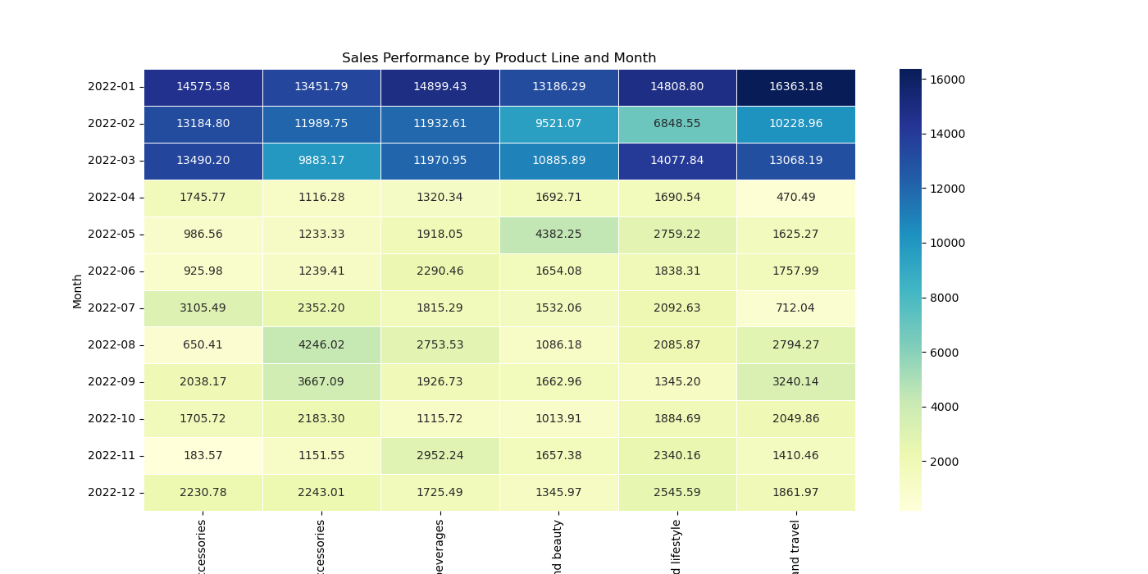

The analysis of the data about the values of the sales performance by the product line for the months of 2022 provides several important tendencies and conclusions.

The company’s product line, Electronic Accessories, maintained a high level of sales all through the year, with the highest recorded in January as well as March. This implies that consumers are very active in purchasing electronics possibly pulled by special offers or new products in the market. The sales in other months were relatively moderate implying that there was constant market for electronic products.

It was for “Fashion Accessories” that the sales figures were volatile. The large number of sales was recorded during January and then sales reduced in the following months, then slightly increased in the last quarter of the year. Such a pattern can be indicative of the fact that fashion accessories could be influenced by seasonal effects and promotions that affect their sales profoundly.

The “Food and Beverages” has recorded lower sales in the first four month of the year and then slightly increased by end of the year. This may depict the different customers’ trends or the fluctuating factors within a specific month that may affect food and drinks consumption.

For instance, the sales that were recorded in the “Health and Beauty” category were high at January, assuming the peak on this month. Nevertheless, the sales records stabilized in the preceding months and only increased slightly towards the yearend. This might be due to some factors like seasonal changes or changes in consumer behaviour.

‘Home and Lifestyle’ was one of the bestperforming categories, especially in terms of January sales and steady, constant sales for the entire year. This relative stability implies continued patronage of home and lifestyle products, which may have been fueled by such phenomena as continued home improvement, or change of lifestyle.

Sales fluctuated for the “Sports and Travel” magazine as shown below with January having the highest sales. Monthly sales were quite volatile and could be explained by the effect of seasonal factors, for example, sports events or travelling.

Thus, the analysis of data allows us to speak about the seasonality and promotions impact on various product portfolios. The electronic products and fashion accessories have widely variations, whereas home and lifestyle have steady sales.

# Sales By Days of Week

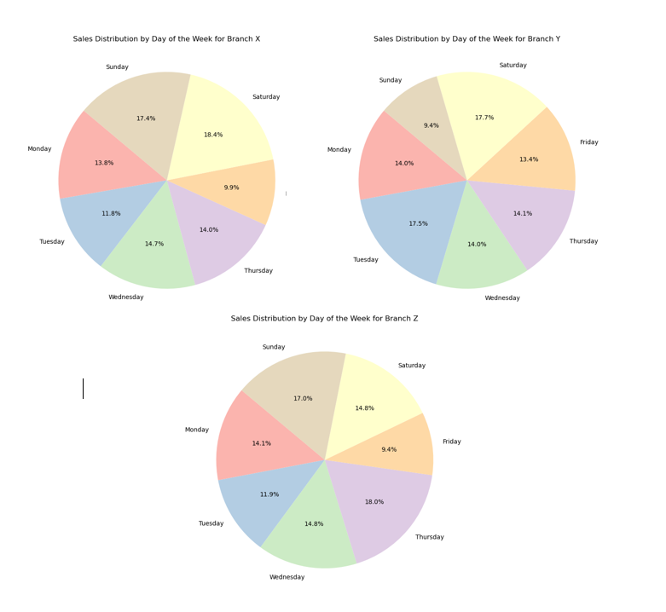

The data for Branch X shows us that Saturday and Sunday are the heaviest sales days, respectively contributing to 35.8% of weekly sales: This serves to underline the significance of weekends for this branch and indicates that these are busy days, where it is vital that high revenues can be achieved. By contrast, Friday only accounts for 9.9%, which indicates a possible window of opportunity to boost sales by way of some BlackFridaylike promotion or special offer.

Branch Y: Tuesday – 17.5%, Saturday – 17.7% This pattern suggest that this branch has particularly strong weekdays and weekends. In contrast, Sunday accounts to 9.4%, which reveals a potential opportunity window to max out returns for that day (b)

Thursday has the highest percentage of weekly sales at 18% for Branch Z, Then Sunday with 17%. This can tell the same branch that Thursday and Sunday are days when sales will be high. A minimal portion 9.4% happens on a Friday, suggesting to implement some plans or strategies that can boost sales on this day.

percentage controller analysis shows us weekends are always high on all centers and marketers must concentrate more towards implementing promotional strategies there. On the other hand, some days like Tuesday for Branch Y and Thursday for Branch Z should be made full promotional agents to make more out of highsales period.

# Sales By Customer Type

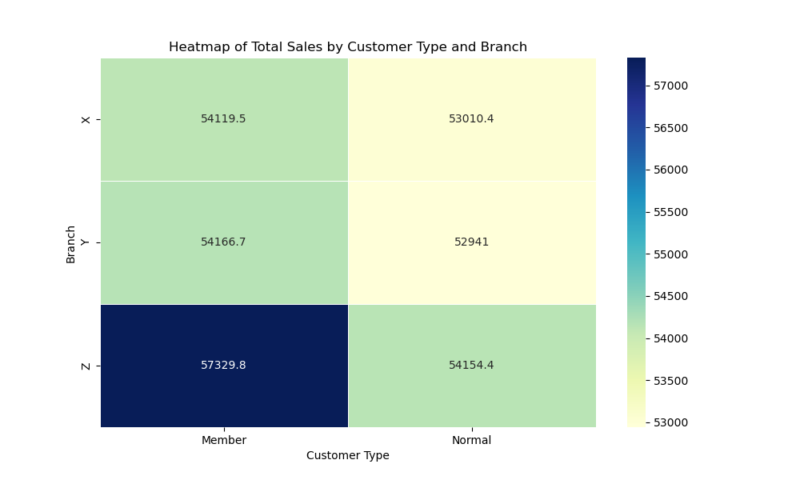

Looking at the graph shows that regardless of the branch type the customer type Member contribute more into the total revenue/sales as compared to normal customers

# Business Strategy/ Decisions for Future

According to the above analysis different branches of the store need different strategies for the upcoming year to increase their sales and profit,

Branch X status: continue to promote "Home and Lifestyle" product line as it has started well in sales during the year.

Branch Y will do well push on "Electronic Accessories" since they are doing good in the MIDDLE season.

For “Food and Beverages”: Branch Z should keep a healthy stock along with marketing efforts, particularly during the month of December and January when this category finds remarkable traffic.

Branch Y should work towards improving its promotions on Sundays to increase the rebound. Also, Branch Z needs to seek a better approach toward boosting its Friday sales — the figure still occupies less of their weekly sale.

As a Branch Z, you’d definitely want to look into what Branch A and B are doing as far as driving revenue growth in August & September for all other periods of the year. Branch X can mitigate sales fluctuations by executing direct marketing strategies, leading to a more consistent performance. The yearly promos, especially for December of Branch Y will be waited on to increase sales before the year ends.

The fact is, that weekday sales can improve performance even more so. Branch X might benefit most from the decision to run ads on Fridays, as Friday yields may be less than other days forcing up ad sales.

With the use of these insights being implemented in each branch, a number of strategies can be specially made to help cater towards customer demands and profitability pedestrian on type.

Analyzing the Member vs Normal Customer contribution the store should focus more on strategies for memberships.